

Project Name- STUDENT-PERFORMANCE CALCULATOR

COURSE NAME- Software Engineering
COURSE CODE- CSE404
Submitted to
Md. Rakib Hossain
Senior Lecturer
CSE, ULAB
Software Engineering
Submitted by

Name | ID
Apurba Sarkar | 151014003
Ahsiqur Rahman | 151014028
Mousumi Khan | 152014027
Sanjida Siddiqua | 151014055

s
SCENARIO-BASED MODELING Page
4.1 Introduction 5
4.2 Use Case Diagrams and Scenario 6
4.3 Conclusion 35
5.1 Data Modeling Concept 37
5.2 Create Data Relationship Diagram 37
5.3 Entity Relationship (ER) Diagram 39
5.4 Conclusion 39
6.1 Class Based Modeling Concept 41
6.2 Class Diagram for STUDENT-PERFORMANCE CALCULATOR STUDENT-PERFORMANCE CALCULATOR 41
6.3 Conclusion 43
7.1. Introduction 44
7.2. Data Flow Diagram (DFD)
7.3 Conclusion 45
8.1. Introduction 46
8.2. Future Plans 46
8.3. Conclusion 46
9.1 Questionnaires 47
9.2 References 47

ALL FIGURES AND TABLES LIST

Table 4(a) Use Case Scenario 5

Fig: Use case (b): STUDENT-PERFORMANCE CALCULATOR
(level 1) 6

Fig: Use case (c): Authentication (level 1.1) 9
Use Case Description (a): Create Account/Registration------------------------------------------------10
Fig: Activity diagram (a): Registration (level 1.1.1)----------------------------------------------------11

Use Case Description (b): Log in 12

Fig: Activity diagram (b): Log in (level 1.1.2) 13

Use Case Description Table (c): Log Out 14

Fig: Activity diagram (c): Log out (level 1.1.3) 15

Fig: Swimlane diagram (c): Log Out (level 1.1.3) 16

Use Case Description (d): Can view –All Information of any student ------------17

Fig: Activity diagram (d): Can view –All Information of any student (level 1.1.4-18

Fig: Swimlane diagram (d) Can view –All Information of any student (level 1.1.4)-
19
Use Case Description (e): Calculate result----------------------------------------------20
Fig: Activity diagram (e): Calculate result (level 1.1.5)------------------------------21
Fig: Swimlane diagram (e) Calculate Result (level 1.1.5)--------------------------------------------22
Use Case Description (f): Update profile-----------------------------------------------23
Fig: Activity diagram (f): Update Profile (level 1.1.6)--------------------------------24
Fig: Swimlane diagram (f) Update profile (level 1.1.6)-------------------------------25
Use Case Description (g): Can view – Upload student result------------------------26
Fig: Activity diagram (g): Upload student result (level 1.1.7) -----------------------27
Fig: Swimlane diagram (g) Upload student result (level 1.1.7)-----------------------28
Use Case Description (h): Maintain &Update--------------------------------------------------29
Fig: Activity diagram (h): Maintain &Update (level 1.1.8)--------------------------------30
Fig: Swimlane diagram (h): Maintain &Update (level 1.1.8)------------------------------30
Use Case Description (i): Can Search-------------------------------------------------------------31
Fig: Activity diagram (i): Can Search (level 1.1.9)-------------------------------------------32
Fig: Swimline diagram (i): Can Search (level 1.1.9)-----------------------------------------33
Fig 5(a): Data Objective and Attributes-----------------------------------------------------------35
Fig 5(b): Data Relationship Diagram--------------------------------------------------------------36
Fig 5(a): Entity Relationship Diagram------------------------------------------------------------37
Fig 6(a): Class Diagram-------------------------------------------------------------------------------40
Fig 7(a): data-flow diagram (Context level)----------------------------------------------------41
Fig 7(b): data-flow diagram (level 0)-------------------------------------------------------------42

Chapter 4

Scenario-based modeling of STUDENT-PERFORMANCE CALCULATOR

This chapter describes the scenario-based modeling of STUDENT-PERFORMANCE CALCULATOR

4.1 Introduction

Scenario based modeling comprises of three parts:

- Use case diagram
- Activity diagram
- Swimlane diagram

Based on the scenario discussed on previous chapter, you have to designed use case diagram, activity diagram and swimlane diagram of the project.

A use case diagram is a graphic depiction of the interactions among the elements of a system. A use case is a methodology used in system analysis to identify, clarify, and organize system requirements and it contains some components.

- The actors, usually individuals involved with the system defined according to their roles.

- The use cases, which the specific roles are played by the actors within and around the system.

- The relationships among the actors and the use cases.

In STUDENT-PERFORMANCE CALCULATOR the use case diagram represents the whole process and activities of managing user and administrator Operation University of Liberal Arts Bangladesh. The actors are to be identified from the scenario.

These actors are of two types.

- Primary actor

- Secondary actor
Primary actor: The actors those both produce and consume information of a system.

Secondary actor: The actors those either produce or consume information of a system.

The identified actors of STUDENT-PERFORMANCE CALCULATOR are:

- Faculty/ Admin

- Student
4.2 Use Case Diagrams and Scenario

In this section use case diagram and scenario are described elaborately. Each use case diagram contains its name, level number, primary and secondary actors.

The scenario of the first use-case diagram is provided in previous chapter as it represents the whole scenario of the STUDENT-PERFORMANCE CALCULATOR
Use Case Scenario

Level 0  STUDENT-PERFORMANCE CALCULATOR | Level 1  Authentication | Level 2  Create Account  Login  Logout  Can view –All Information of any student  Calculate result  Update Profile  Upload student result  Maintain &Update  Can Search | Actors  Admin/Faculty  &  Student  Admin/Faculty  &  Student  Admin/Faculty  &  Student  Admin/Faculty  Admin/Faculty  Admin/Faculty  &  Student  Admin/Faculty  Admin/Faculty  Admin/Faculty  &  Student

Table 4(a) Use Case Scenario

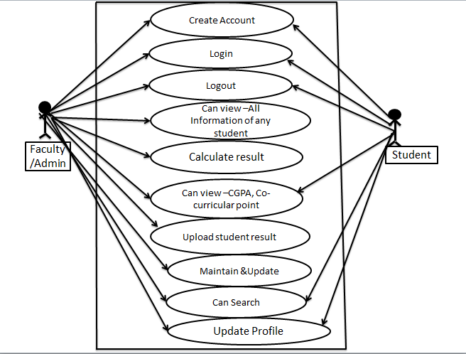

Fig: Use case (b): STUDENT-PERFORMANCE CALCULATOR (level 1)

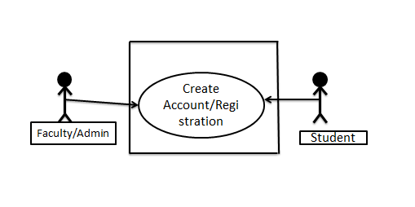
Fig: Use case (c): Authentication (level 1.1)

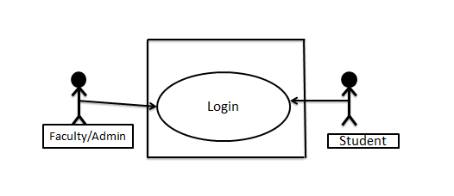
Fig: Use case (c): Authentication (level 1.2)

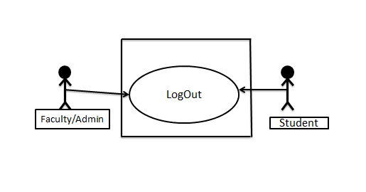
Fig: Use case (c): Authentication (level 1.3)

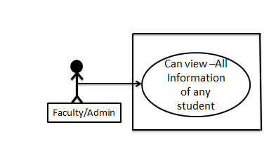
Fig: Use case (c): Authentication (level 1.4)

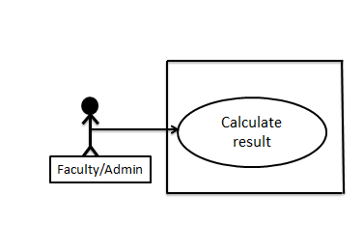
Fig: Use case (c): Authentication (level 1.5)

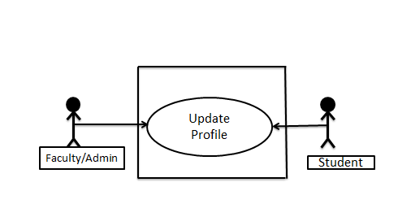

Fig: Use case (c): Authentication (level 1.6)

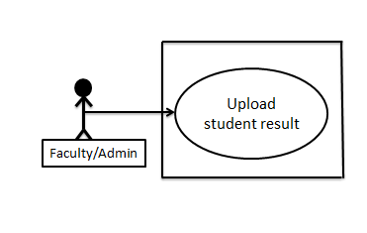
Fig: Use case (c): Authentication (level 1.7)

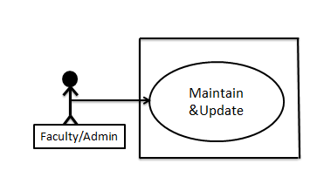
Fig: Use case (c): Authentication (level 1.8)

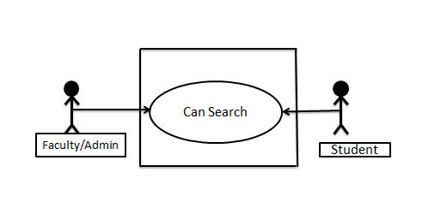
Fig: Use case (c): Authentication (level 1.9)

- Use Case Description: Create Account/Registration

Use Case Id | Level 1.1.1
Use Case Name | Create Account/Registration
Primary Actor | Admin/Faculty  &  Student
Secondary Actor | none
Goal in Context | To enter the system.
Precondition | Must have Internet
Scenario | 1. | Input User name or User ID & Password.
Priority | Essential, must be implemented.
When Available | First increment.
Frequency of Use | Many times, per day.

Use Case Description (a): Create Account/Registration

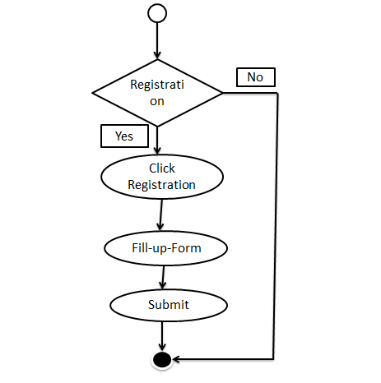

Fig: Activity diagram (a): Registration (level 1.1.1)

b)Use Case Description: Login

Use Case Id | Level 1.1.2
Use Case Name | Login
Primary Actor | Admin/Faculty  &  Student
Secondary Actor | none
Goal in Context | To enter the system.
Precondition | Must have an account
Scenario  Exception | . | 1. Unrecognized user-name or user id.  2. Incorrect Password.  3. User is blocked.
  1. | 1. Click on „Log In‟ button.
  2. | 2. Input User name or User ID & Password.
  3. | 3. Proceed to the next activity.
Priority | Essential, must be implemented.
When Available | After 1st increment.
Frequency of Use | Many times, per day.

Use Case Description (b): Login

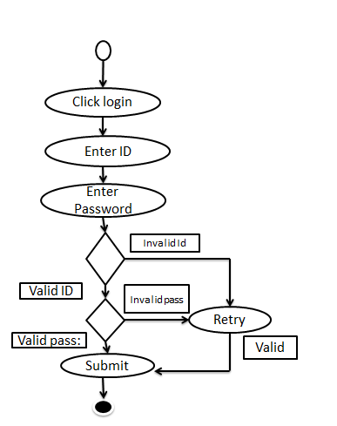

Fig: Activity diagram (b): Log in (level 1.1.2)

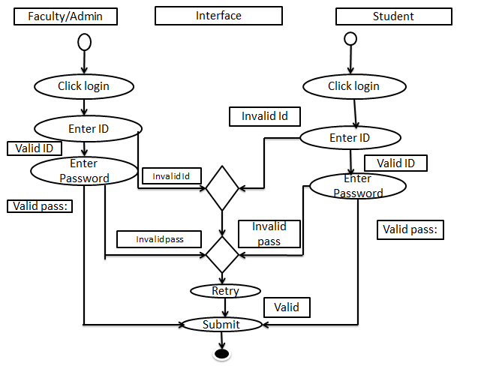

Fig: Swimlane diagram (a): Log in (level 1.1.2)

(c)Use Case Description: Log Out

Use Case Id | Level 1.1.3
Use Case Name | Log Out
Primary Actor | Admin/Faculty  &  Student
Secondary Actor | none
Goal in Context | To exit from the system.
Precondition | Must be logged in.
Scenario | 1. | Click the „Log Out‟ button.
 | 2. | Get out of the system.
Exception | 1. | System error.
 | 2. | Network error.
Priority | Essential, must be implemented.
When Available | Last increment.
Frequency of Use | Many times, per day.

Use Case Description Table (c): Log Out

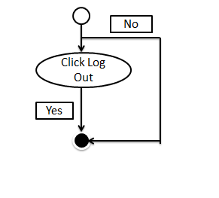
Fig: Activity diagram (c): Log out (level 1.1.3)

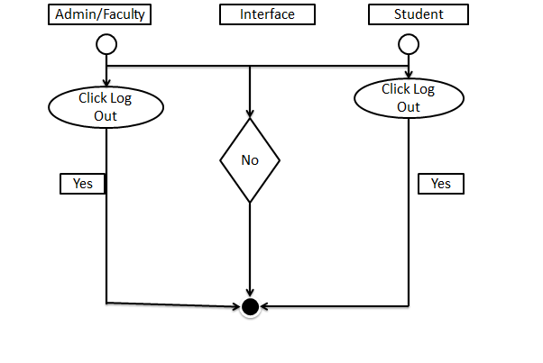

Fig: Swimlane diagram (c): Log Out (level 1.1.3)

d)Use Case Description: Can view –All Information of any student

Use Case Id | Level 1.1.4
Use Case Name | Can view –All Information of any student
Primary Actor | Admin/Faculty
Secondary Actor | none
Goal in Context | view all Information of any student
Precondition | Must be log in.
Scenario | 1. | Click the „Login
 | 2. | Input S_ID/Name
Exception | 1. | System error.
 | 2. | Network error.
Priority | Not Essential
When Available | After 2nd increment.
Frequency of Use | Many times, per day.

Use Case Description (d): Can view –All Information of any student

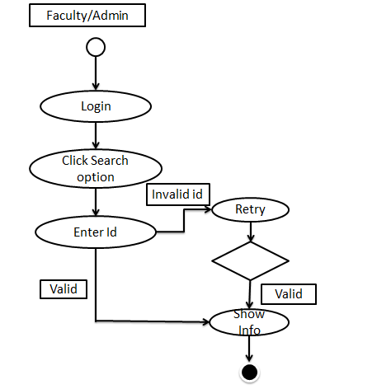

Fig: Activity diagram (d): Can view –All Information of any student (level 1.1.4)

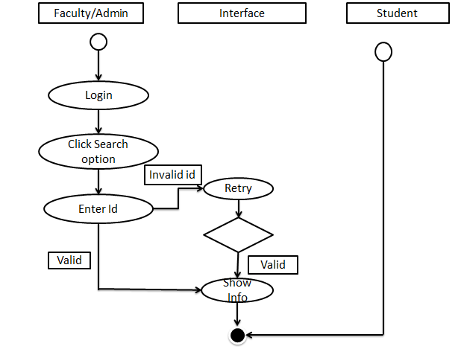

Fig: Swimlane diagram (d) Can view –All Information of any student (level 1.1.4)

e)Use Case Description: Calculate result

 | Level 1.1.5
Use Case Name | Calculate result
Primary Actor | Admin/Faculty
Secondary Actor | none
Goal in Context | Get result
Precondition | Must logged in
Scenario  Exception | .
  1. | 1. Click on „Log In  2.Go to calculator part
  2. | 3.Input CGPA and ex-co-curricular point
  3.
    1)System error.
    2)Network error.
Priority | Not Essential
When Available | After 2nd increment.
Frequency of Use | Many times, per day.

Use Case Description (e): Calculate result

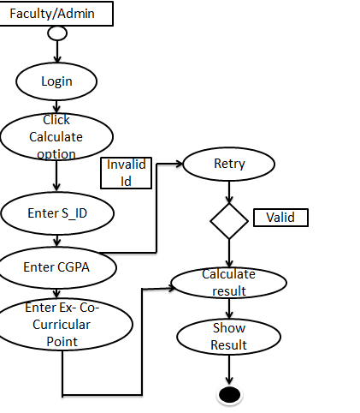
Fig: Activity diagram (e): Calculate result (level 1.1.5)

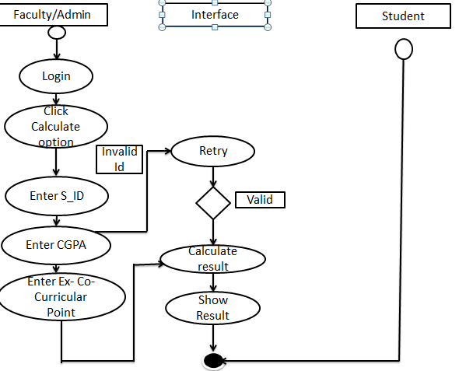
Fig: Swimlane diagram (e) Calculate Result (level 1.1.5)

f)Use Case Description: Update Profile

Use Case Id | Level 1.1.6
Use Case Name | Update Profile
Primary Actor | Admin/Faculty  &  Student
Secondary Actor | none
Goal in Context | Update profile Admin/Faculty & Student
Precondition | Must be log in.
Scenario | 1. | Click the „Login
 | 2. | Go to edit profile
Exception | 1. | System error.
 | 2. | Network error.
Priority | Not Essential
When Available | After 2nd increment.
Frequency of Use | Many times, per day.

Use Case Description (f): Update profile

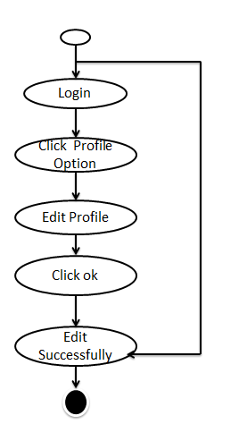

Fig: Activity diagram (f): Update Profile (level 1.1.6)

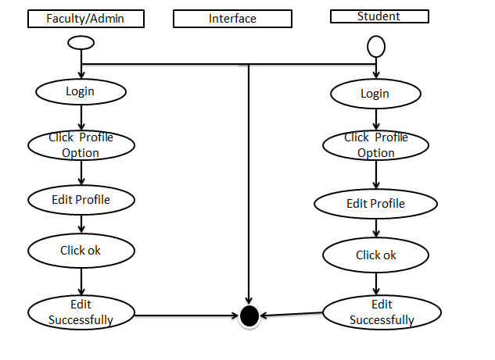

Fig: Swimlane diagram (f) Update profile (level 1.1.6)

g)Use Case Description: Upload student result

 | Level 1.1.7
Use Case Name | Upload student result
Primary Actor | Admin/Faculty
Secondary Actor | none
Goal in Context | upload result
Precondition | Must logged in
Scenario  Exception | .
  1. | 1. Click on „Log In  2.Go to calculator part
  2. | 3.Input CGPA and ex-co-curricular point  4.Get Result  5.Upload result
  3.
    1) System error.
    2) Network error.
Priority | Not Essential
When Available | After 2nd increment.
Frequency of Use | Many times, per day.

Use Case Description (g): Can view – Upload student result

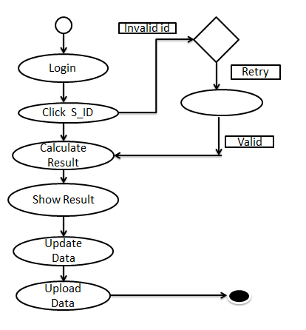
Fig: Activity diagram (g): Upload student result (level 1.1.7)

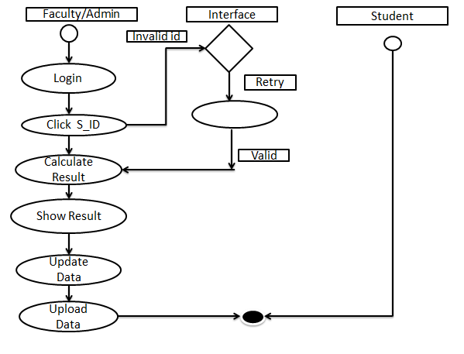
Fig: Swimlane diagram (g) Upload student result (level 1.1.7)

h) Use Case Description: Maintain &Update

 | Level 1.1.8
Use Case Name | Maintain &Update
Primary Actor | Admin/Faculty
Secondary Actor | none
Goal in Context | Maintain &Update data
Precondition | Must logged in
Scenario  Exception | .
  1. | 1. Click on „Log In  2.Go to admin panel
  2.
  3.
    1) System error.
    2) Network error.
Priority | Essential & Implemented
When Available | After 2nd increment.
Frequency of Use | Many times, per day.

Use Case Description (h): Maintain &Update

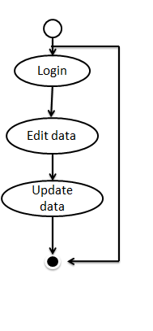
Fig: Activity diagram (h): Maintain &Update (level 1.1.8)

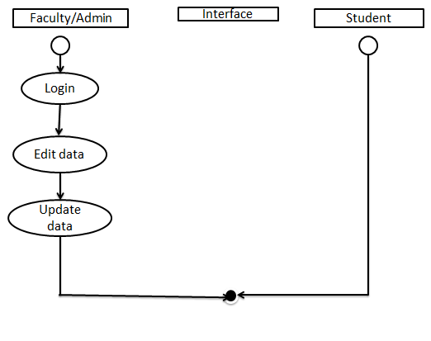
Fig: Swimlane diagram (h): Maintain &Update (level 1.1.8)
i) Use Case Description: Can Search

 | Level 1.1.9
Use Case Name | Can Search
Primary Actor | Admin/Faculty  &  Student
Secondary Actor | none
Goal in Context | View info
Precondition | Must logged in
Scenario  Exception | .
  1. | 1. Click on „Log In  2.Go to search option
  2.
  3.
    1) System error.
    2) Network error.
Priority | Not Essential
When Available | After 2nd increment.
Frequency of Use | Many times, per day.

Use Case Description (i): Can Search

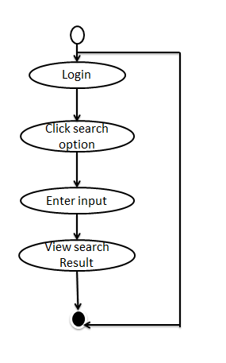

Fig: Activity diagram (i): Can Search (level 1.1.9)

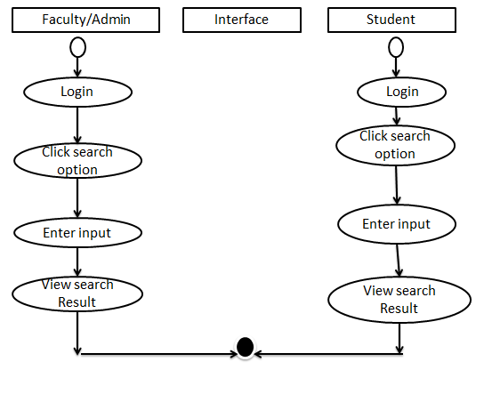
Fig: Swimline diagram (i): Can Search (level 1.1.9)

4.3 Conclusion

To understand scenario-based modeling, you first need to understand requirements modeling and how it applies to software engineering in general. Requirements modeling is essentially the planning stage of a software system or application. The path by which such a system or application comes to life will generally begin with a business or entity identifying a problem they're facing that requires a software solution, and they approach a software development team to come up with this solution. Requirements modeling is the process of identifying the requirements this software solution must meet in order to be successful[8]

Chapter 5

Data Model of Student performance calculator

5.1 Data Modeling Concept

Data modeling is the process of documenting a complex software system design as an easily understood diagram, using text and symbols to represent the way data needs to flow. The diagram can be used to ensure efficient use of data, as a blueprint for the construction of new software or for re-engineering a legacy application. This structure is often represented graphically in entity-relationship diagrams (ERD).
The data model of our project contains important architectural information and serves the following practical purposes:

- Provide a conceptual design of objects in the system’s domain and their relationships.

- Provide a blueprint for creating the database structure.

- Guide implementation of code units that access the database.

- Guide performance enhancement in data access operations.

A set of following activities is done to design the Data Model.

- Create Data Relationship Diagram

- ER Diagram

- Table or Schema Generation

5.2 Create Data Relationship Diagram

An Entity Relationship (ER) Diagram is a type of flowchart that illustrates how “entities” such as people, objects or concepts relate to each other within a system. ER Diagrams are most often used to design or debug relational databases in the fields of software engineering, business information systems, education and research. Also known as ERDs or ER Models, they use a defined set of symbols such as rectangles, diamonds, ovals and connecting lines to depict the interconnectedness of entities, relationships and their attributes.[5]

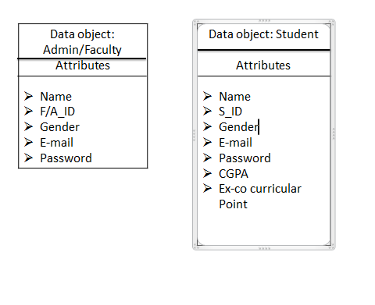

Fig 5(a): Data Objective and Attributes

Student

Student
Student

Student

Admin/Faculty

Admin/Faculty

Admin/Faculty

Admin/Faculty

Admin/Faculty

Create

View

Update

View

Create

View

Calculate result

Upload

Update

Fig 5(b): Data Relationship Diagram
Account/Registration

Result

Profile

CGPA, Co-curricular point

Account/Registration

Student-Info

Result

Result

Profile

5.3 Entity Relationship (ER) Diagram

An Entity Relationship (ER) Diagram is a type of flowchart that illustrates how “entities” such as people, objects or concepts relate to each other within a system. ER Diagrams are most often used to design or debug relational databases in the fields of software engineering, business information systems, education and research. Also known as ERDs or ER Models, they use a defined set of symbols such as rectangles, diamonds, ovals and connecting lines to depict the interconnectedness of entities, relationships and their attributes. They mirror grammatical structure, with entities as nouns and relationships as verbs. [6]
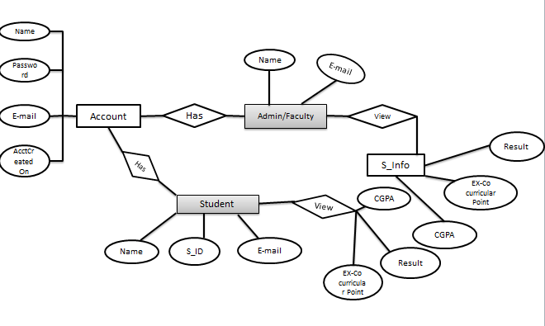
Fig 5(a): Entity Relationship Diagram

5.4 Conclusion

An ER diagram shows the relationship among entity sets. An entity set is a group of similar entities and these entities can have attributes. In terms of DBMS, an entity is a table or attribute of a table in database, so by showing relationship among tables and their attributes, ER diagram shows the complete logical structure of a database.[7]

Chapter 6

Class-based model of STUDENT-PERFORMANCE CALCULATOR

This Chapter is intended to describe class based modeling of STUDENT-PERFORMANCE CALCULATOR

6.1 Class Based Modeling Concept

Class-based modeling is a stage of requirements modeling. In the context of software engineering, requirements modeling examines the requirements a proposed software application or system must meet in order to be successful. Class-based objects support a programming model where you design and instantiate objects based on strongly-typed classes. Like procedure objects, classes maintain a run-time context that can be accessed by other objects. For class-based objects, this context also can include various types of data (data members and properties), but instead of internal procedures, user-defined functions, and named events, a class-based object’s behavior is provided by methods and class events. Thus, a class-based method is a unit of executable code that has features in common with both internal procedures and user-defined functions, as well as features unique to methods.[2]

6.2 Class Diagram for STUDENT-PERFORMANCE CALCULATOR STUDENT-PERFORMANCE CALCULATOR

Class diagram is a static diagram. It represents the static view of an application. Class diagram is not only used for visualizing, describing, and documenting different aspects of a system but also for constructing executable code of the software application.
Class diagram describes the attributes and operations of a class and also the constraints imposed on the system. The class diagrams are widely used in the modeling of object oriented systems because they are the only UML diagrams, which can be mapped directly with object-oriented languages.[1]

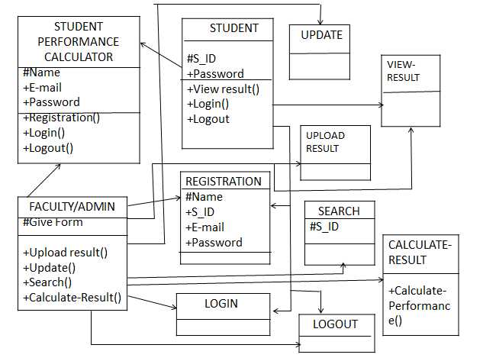

Fig 6(a): Class Diagram

6.3 Conclusion

A class diagram is a type of diagram and part of a unified modeling language that defines and provides the overview and structure of a system in terms of classes, attributes and methods, and the relationships between different classes.

Chapter 7

Data Flow Model of STUDENT-PERFORMANCE CALCULATOR

7.1. Introduction

A data flow diagram (DFD) maps out the flow of information for any process or system. It uses defined symbols like rectangles, circles and arrows, plus short text labels, to show data inputs, outputs, storage points and the routes between each destination. Data flowcharts can range from simple, even hand-drawn process overviews, to in-depth, multi-level DFDs that dig progressively deeper into how the data is handled.[3]

7.2. Data Flow Diagram (DFD)

A Data Flow Diagram (DFD) is traditional visual representation of the information flows within a system. There are four basic symbols that are used to represent a data-flow diagram. The DFD takes an input-process-output view of a system. In the figures, data objects are represented by labeled arrows and transformations are represented by circles.[4] The DFD of our system is given below:
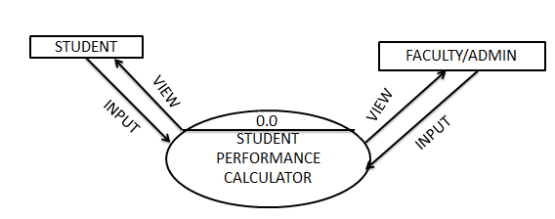

Fig 7(a): data-flow diagram (Context level)

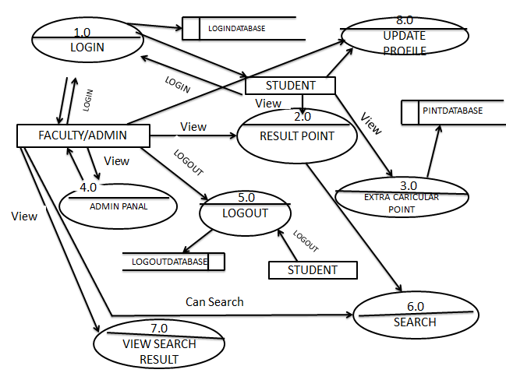

Fig 7(b): data-flow diagram (level 0)

7.3 Conclusion
Data flow diagrams are used to graphically represent the flow of data in a business information system. DFD describes the processes that are involved in a system to transfer data from the input to the file storage and reports generation.
Data flow diagrams can be divided into logical and physical. The logical data flow diagram describes flow of data through a system to perform certain functionality of a business. The physical data flow diagram describes the implementation of the logical data flow.

Chapter 8

Conclusion

8.1. Introduction
Student performance calculator will calculate the performances of a student throughout his entire undergraduate level and will help to identify their performance level as like their cumulative grade point that might help them to give better performance as a student. In our project there will be two different parts. One is administration part another is student part. Administration part will be a desktop application. The administrator will be able to insert update or delete data in the database and manage every required information to calculate the performance. And the student part will be a mobile application where student will log in and see their performance grade.

8.2. Future Plans

Project Features - Student-
1. A dashboard where they can view - Payment information, Total Credit hour complete.
2. Can see live results & Co curricular activities result.
3. Get notifications from University authority any news.
4. Can survey/ evaluation from the apps (Faculty, Course, Students, University)
5. Can give online real-time exam.
Faculty / Admin –
- Online survey
- Online evaluation

8.3. Conclusion
However Student Performance Calculator will provide students with the opportunity of being judged by their performance and get more better opportunities through their performance grade .Administrator will also be able to evaluate a student’s performance easily through this project. Besides there will be more facilities which will help both students and administration.

Chapter 9

Appendix and References

9.1 Questionnaires

9.2 References
- www.tutorialspoint.com. (2018). UML - Class Diagram. [online] Available at: https://www.tutorialspoint.com/uml/uml_class_diagram.htm [Accessed 15 Dec. 2018].
- Documentation.progress.com. (2018). OpenEdge 11.7 Documentation. [online] Available at: https://documentation.progress.com/output/ua/OpenEdge_latest/index.html#page/dvoop/class-based-model.html [Accessed 15 Dec. 2018].
- Lucidchart.com. (2018). Data Flow Diagram Symbols, Types, and Tips | Lucidchart. [online] Available at: https://www.lucidchart.com/blog/data-flow-diagram-tutorial [Accessed 15 Dec. 2018].
- Lucidchart.com. (2018). Data Flow Diagram Symbols, Types, and Tips | Lucidchart. [online] Available at: https://www.lucidchart.com/blog/data-flow-diagram-tutorial [Accessed 15 Dec. 2018].
- Lucidchart.com. (2018). Data Flow Diagram Symbols, Types, and Tips | Lucidchart. [online] Available at: https://www.lucidchart.com/blog/data-flow-diagram-tutorial [Accessed 15 Dec. 2018].
- Lucidchart.com. (2018). ER Diagram Tutorial | Lucidchart. [online] Available at: https://www.lucidchart.com/pages/er-diagrams [Accessed 18 Dec. 2018].
- Tutorials, A., Servlet, L., JSP, L., JSTL, L., C, L., C++, L., MongoDB, L., XML, L., Python, L., Perl, L., Java, C., I/O, J., Singh, C., Kumar, B. and Jahan, T. (2018). Entity Relationship Diagram - ER Diagram in DBMS. [online] beginnersbook.com. Available at: https://beginnersbook.com/2015/04/e-r-model-in-dbms/ [Accessed 18 Dec. 2018].
- Study.com. (2018). [online] Available at: https://study.com/academy/lesson/scenario-based-requirements-modeling-definition-application.html [Accessed 19 Dec. 2018].

